**CNN Project Report**

**TACO Object Detection using YOLOv8**

**Abhay Tyagi 23BAI10001**

**1. Dataset Description**

This project uses the TACO (Trash Annotations in Context) dataset, which is designed for object detection of litter and waste items in real-world scenes. The dataset contains images annotated with bounding boxes and class labels corresponding to different categories of trash. For this project, the dataset is converted and organized in YOLO format, with separate directories for training, validation, and testing images, along with corresponding label files.

**2. Model Architecture**

The model employed is YOLOv8n (You Only Look Once, version 8 -- nano variant), a convolutional neural network optimized for efficient and real-time object detection. YOLOv8 follows a single-stage detection paradigm: CNN backbone for feature extraction, neck for multi-scale feature aggregation, detection head that predicts bounding box coordinates, objectness scores, and class probabilities in a single forward pass.

**3. Workflow**

**Taco Dataset**

**Data Loader**

**(YOLO FORMAT)**

**YOLOv8n**

**Model Init**

**Training**

**Validation**

**Inference**

**Visualization**

This pipeline ensures systematic training and evaluation of the object detection model.

**4. Experimental Setup**

The hardware of this project was my personal laptop, which has an NVIDIA RTX 3070Ti Laptop GPU with 8 GB of VRAM. The experiments were conducted using the PyTorch deep learning framework and the Ultralytics YOLOv8 library. Training was performed for 50 epochs with an input image size of 640×640 pixels and a batch size of 16. GPU acceleration was used during training, however the code allows running without it as well. Default YOLOv8 optimization and loss settings were retained to ensure stable training.

**5. Results**

The trained YOLOv8n model was evaluated on the validation set using standard object detection metrics. The quantitative results obtained are summarized below.

The model achieved a precision of 0.596 and a recall of 0.337, indicating that while the detector is reasonably accurate in its predictions, it misses a significant portion of ground-truth objects. The mean Average Precision at IoU 0.5 (mAP@0.5) was 0.367, while the more stringent mAP@0.5:0.95 was 0.279. These results reflect moderate detection performance on the TACO dataset, which contains cluttered scenes and visually diverse waste objects.

Overall, the evaluation metrics suggest that the model is capable of learning meaningful object representations but still faces challenges in achieving high recall and localization accuracy.

Figures below:

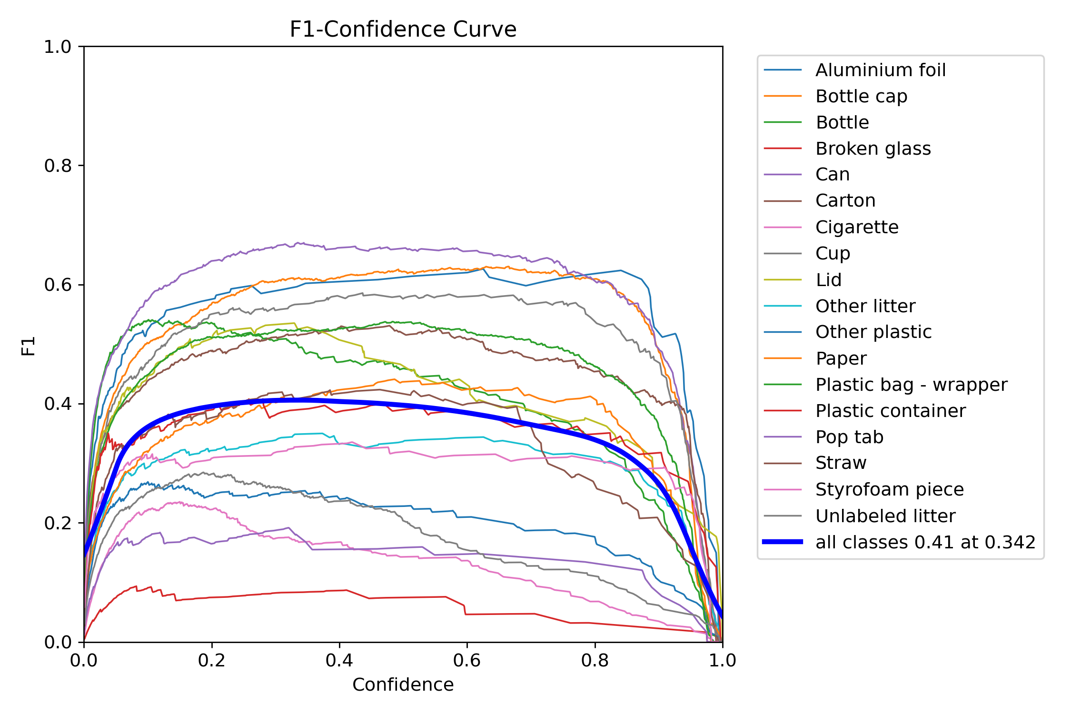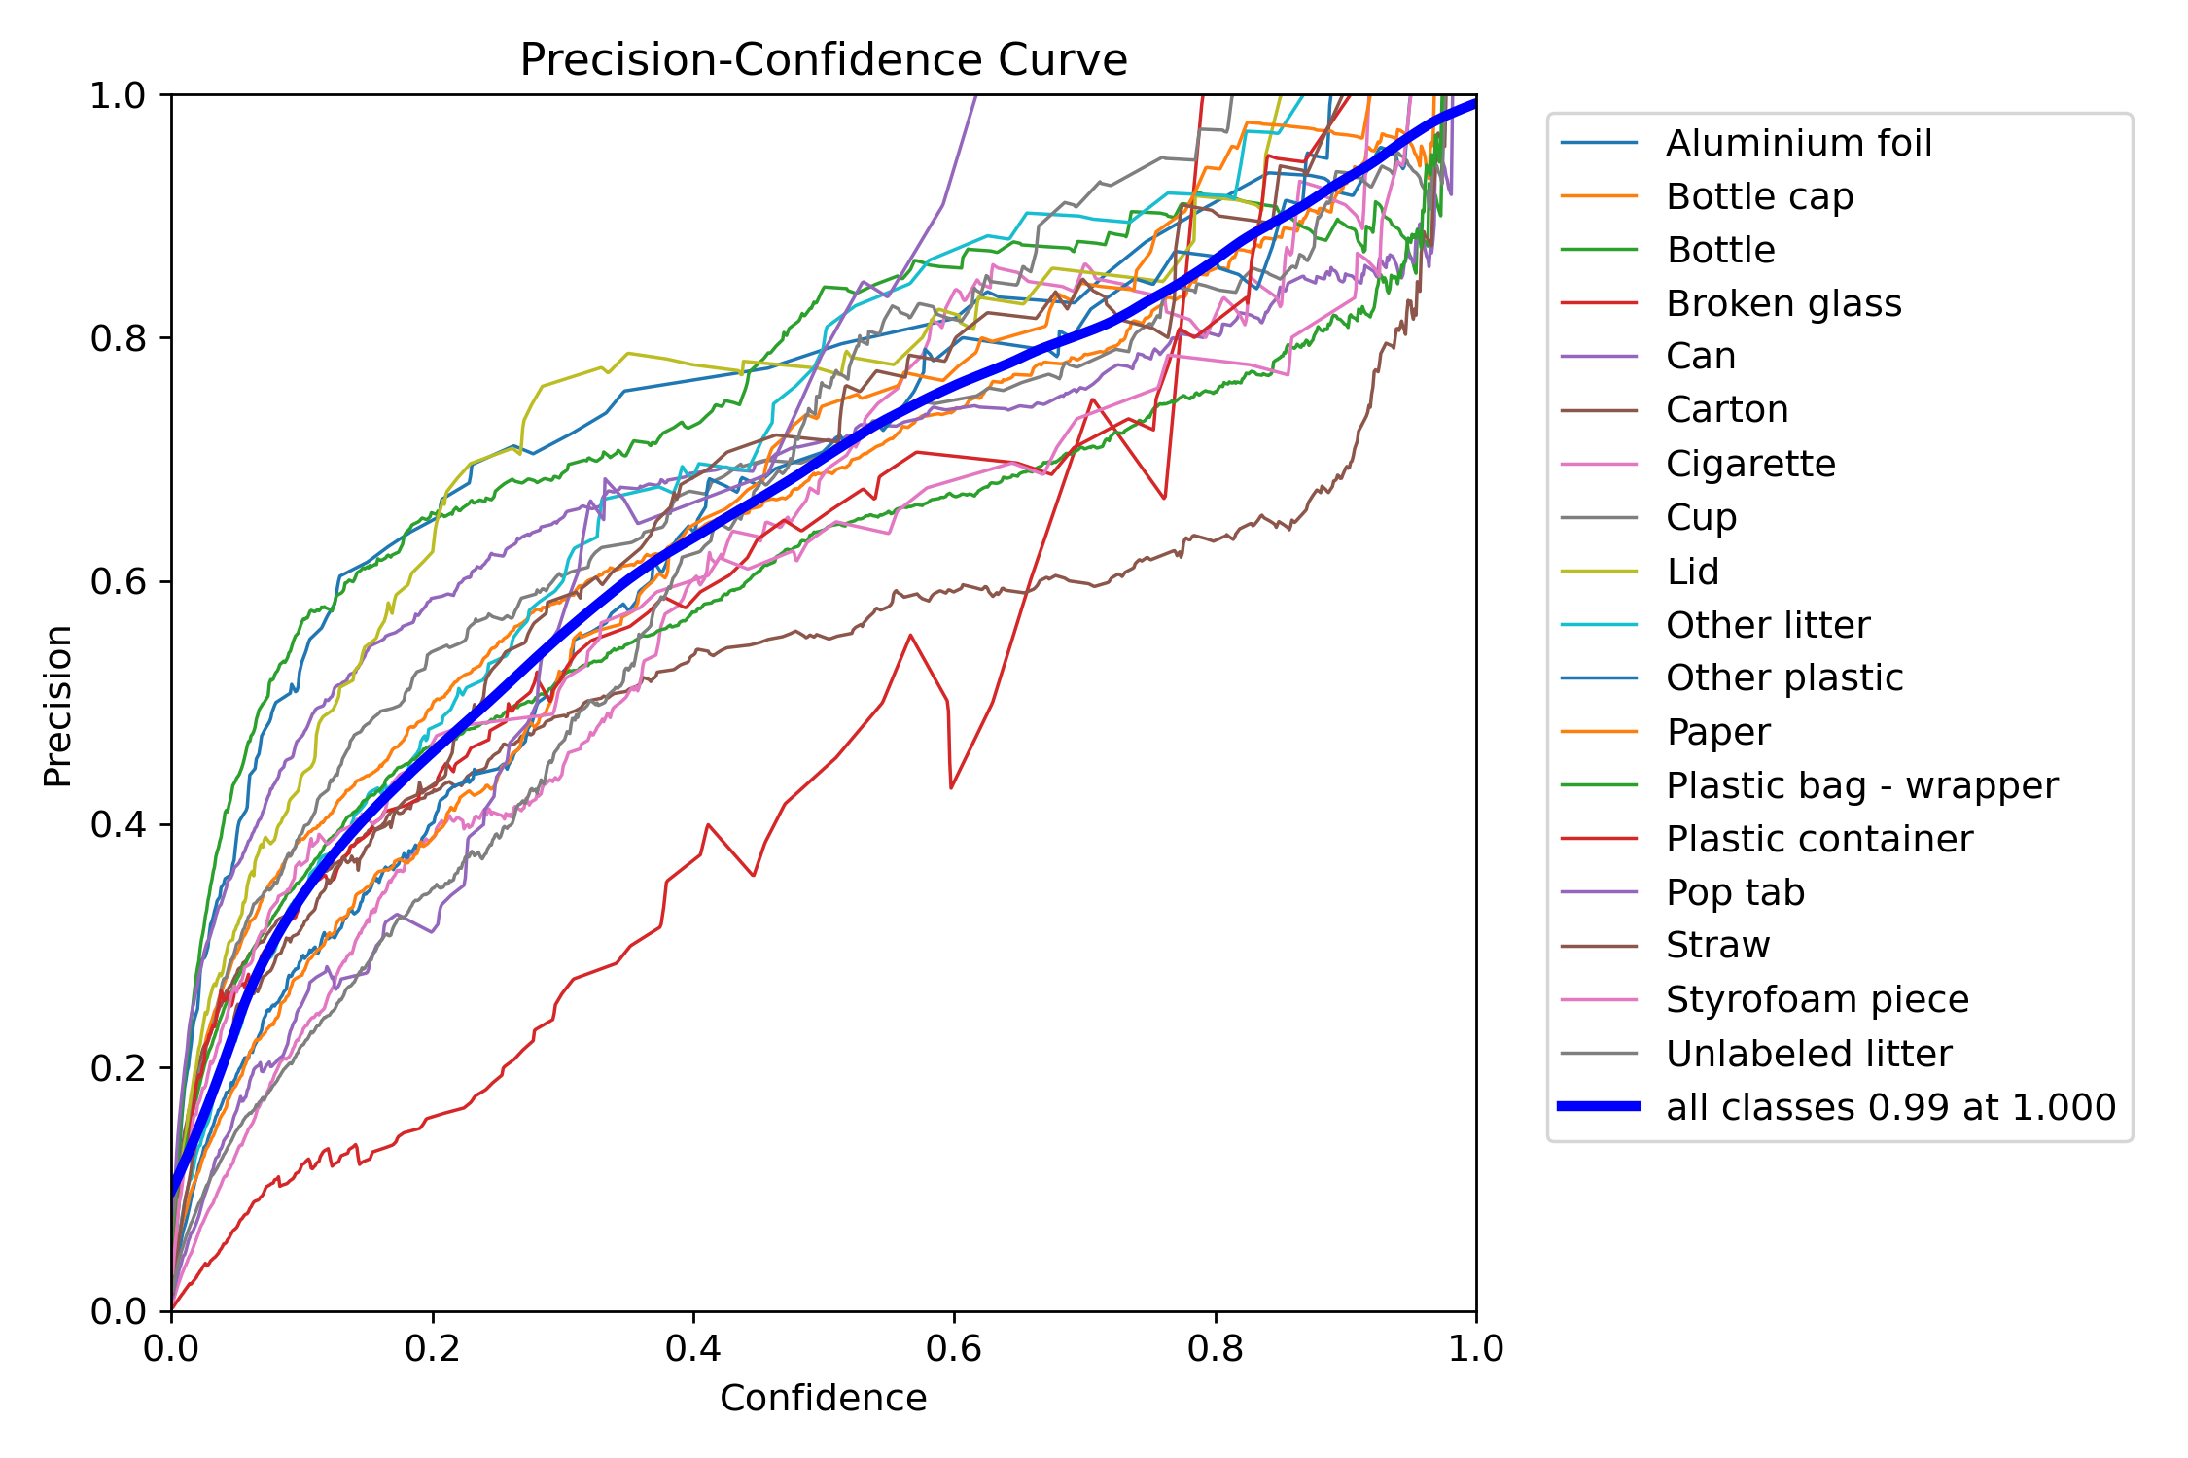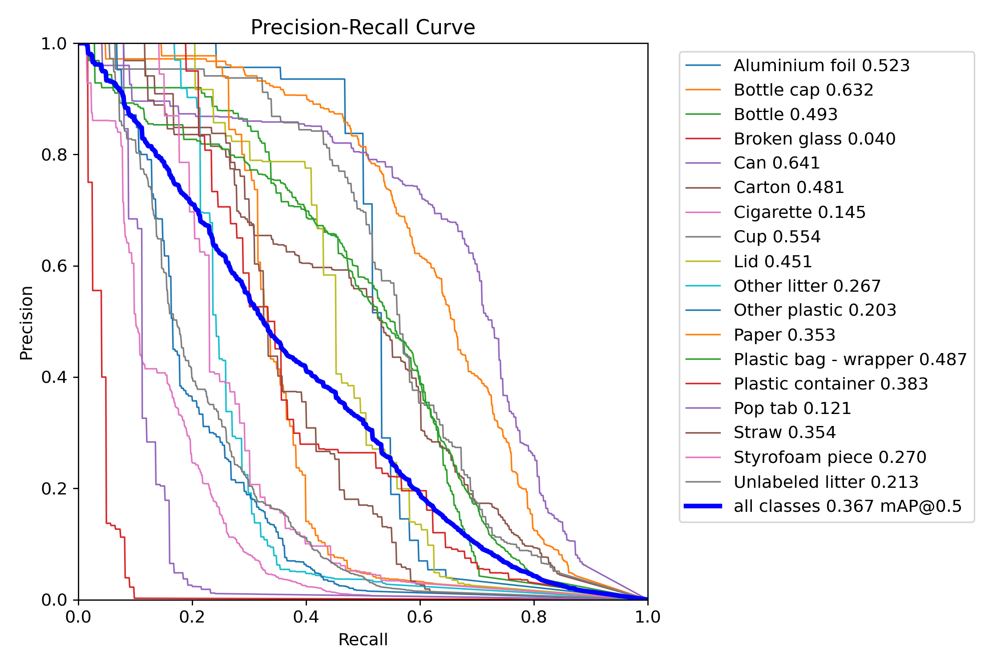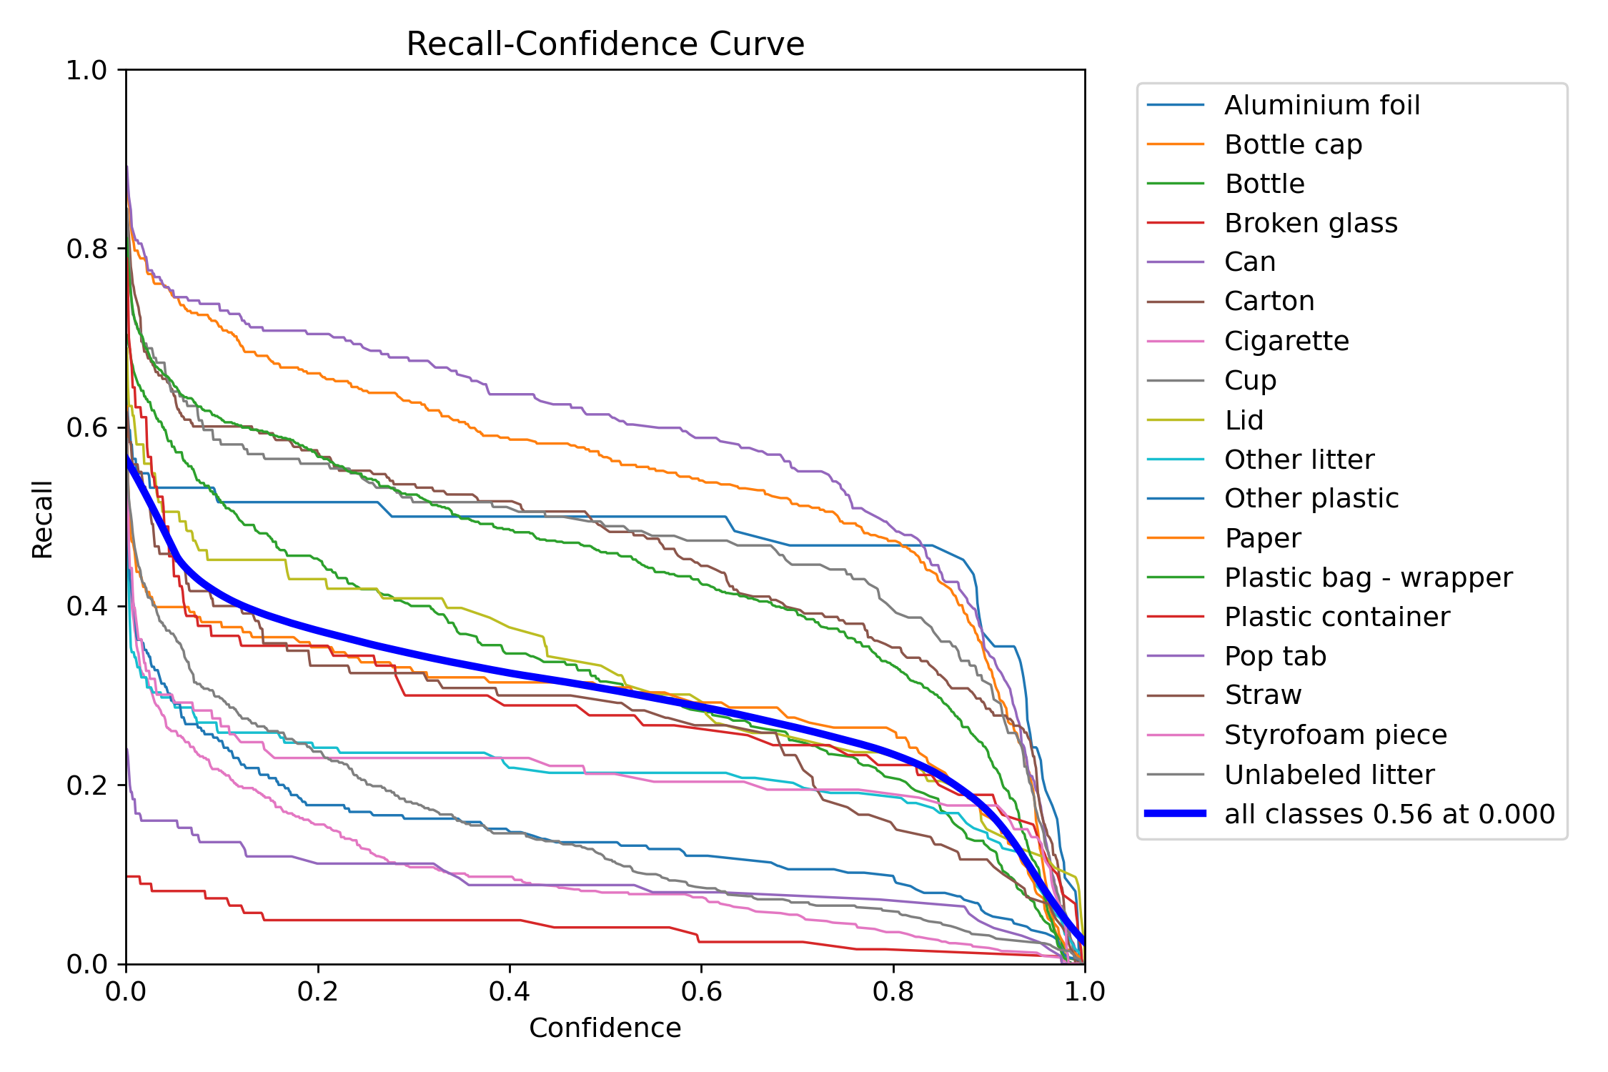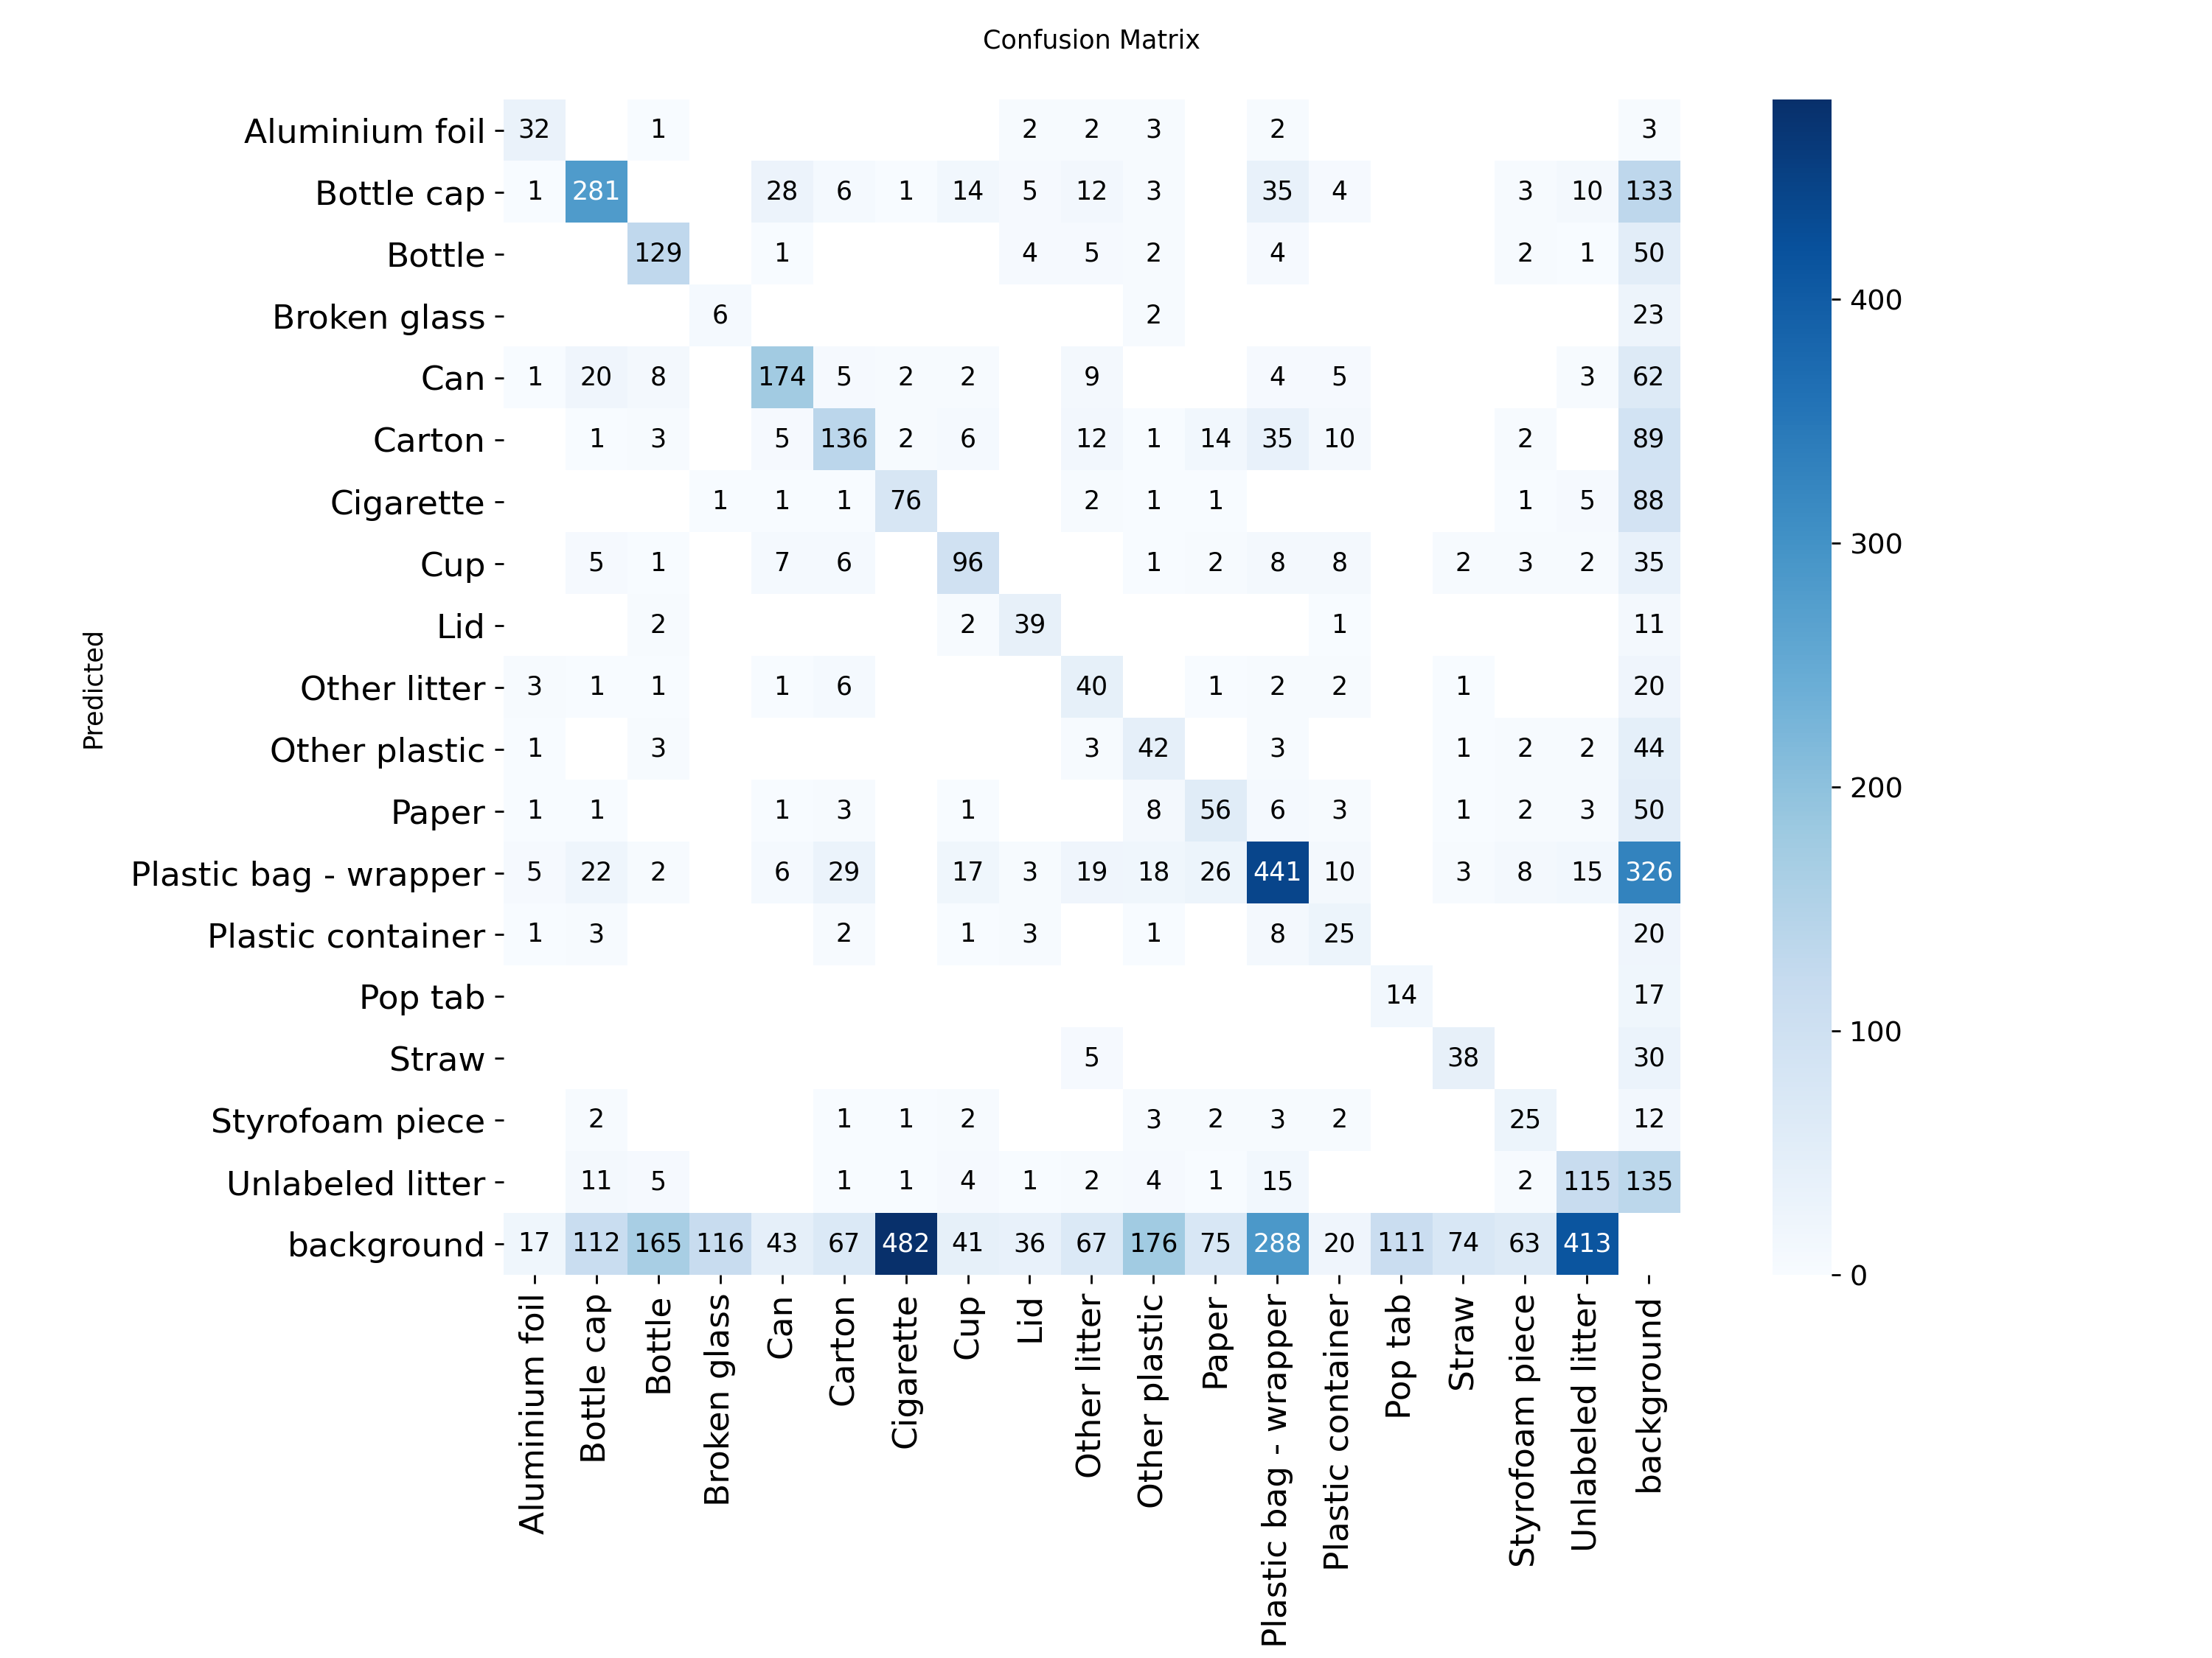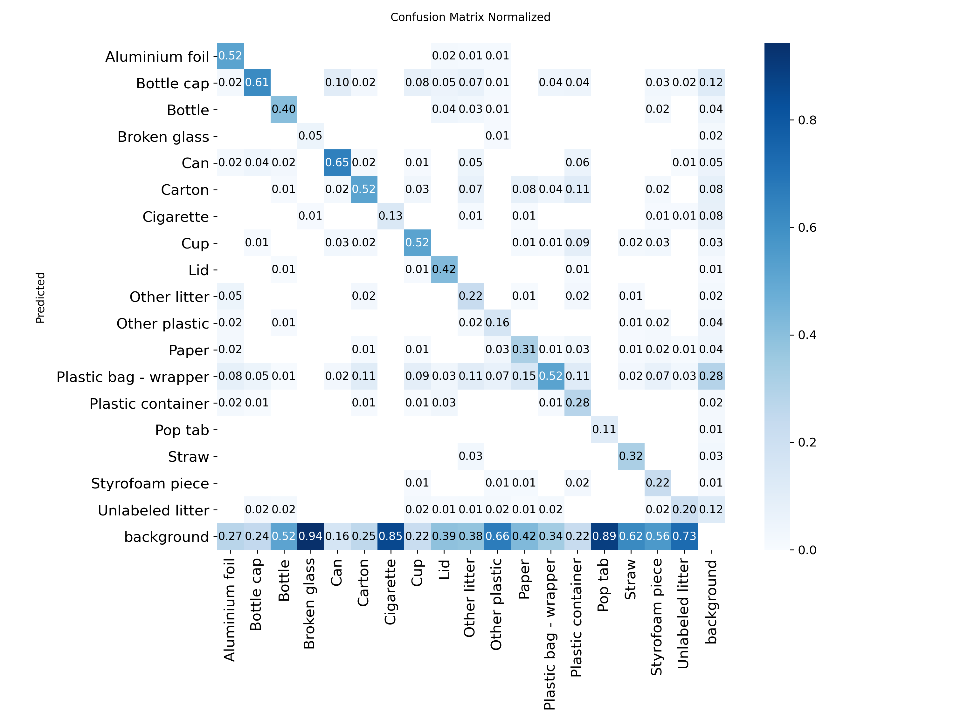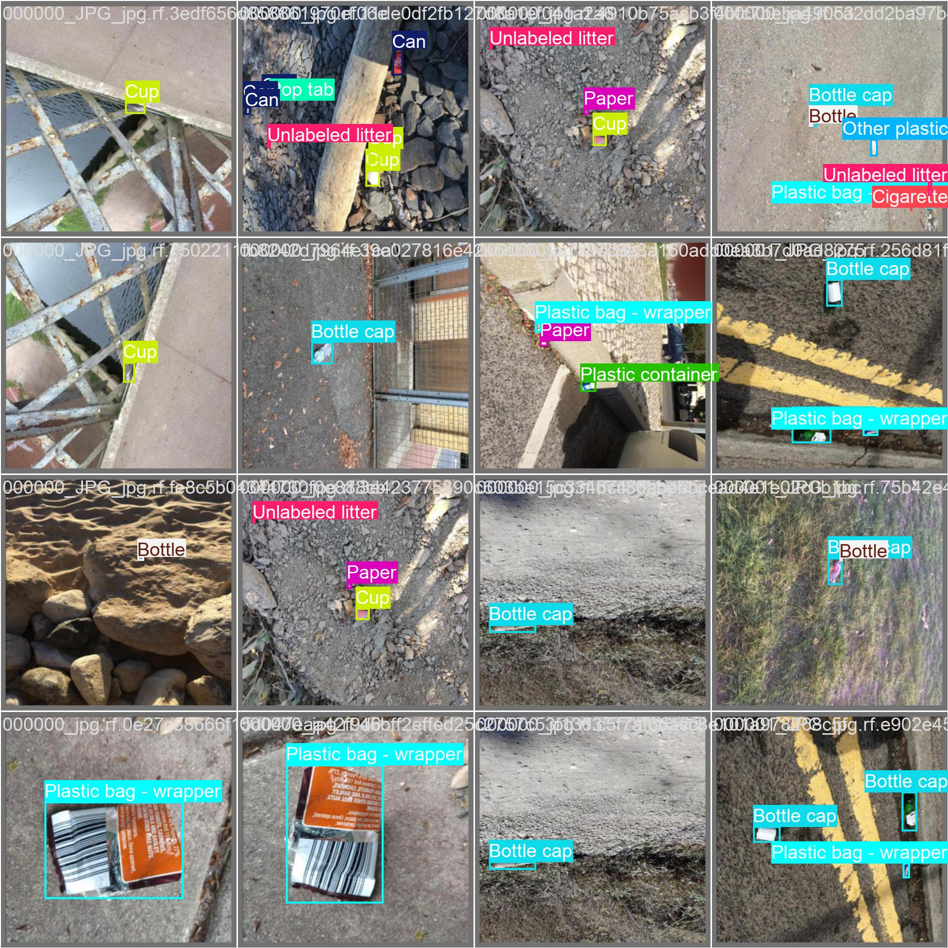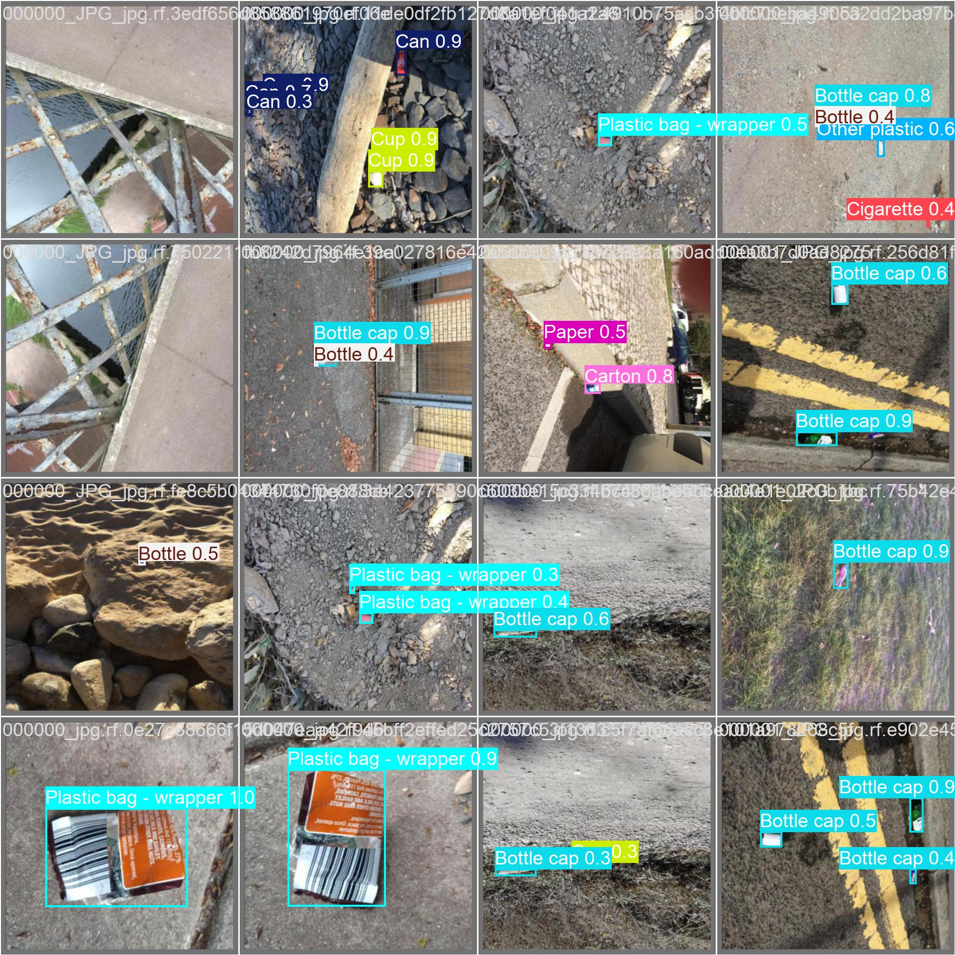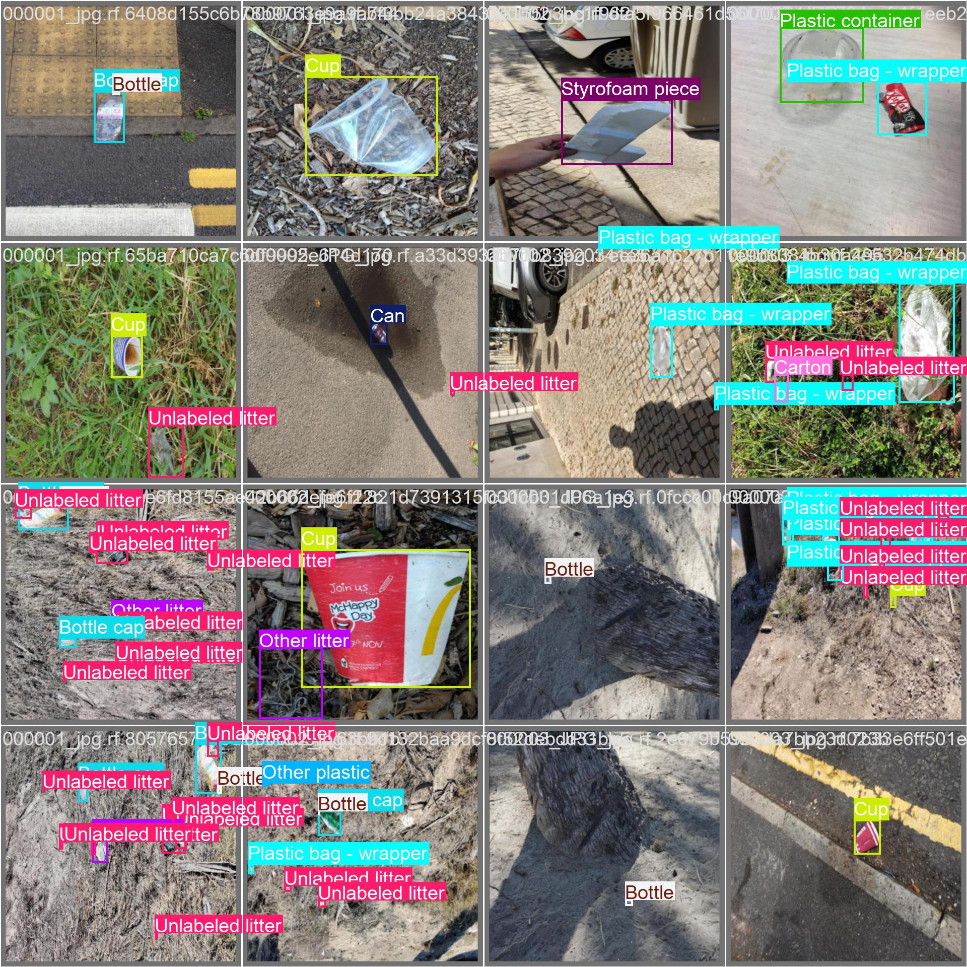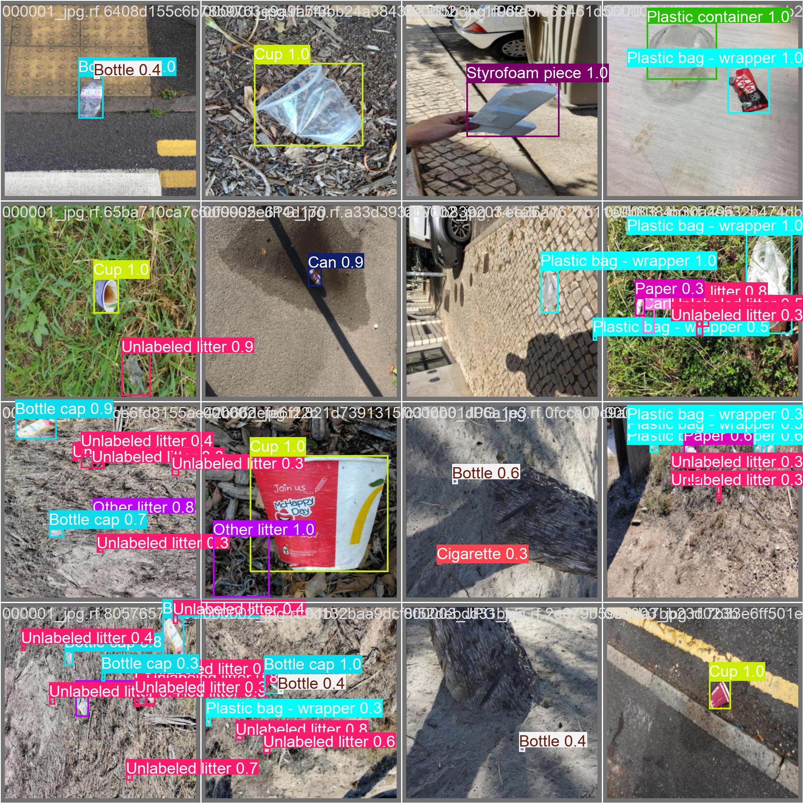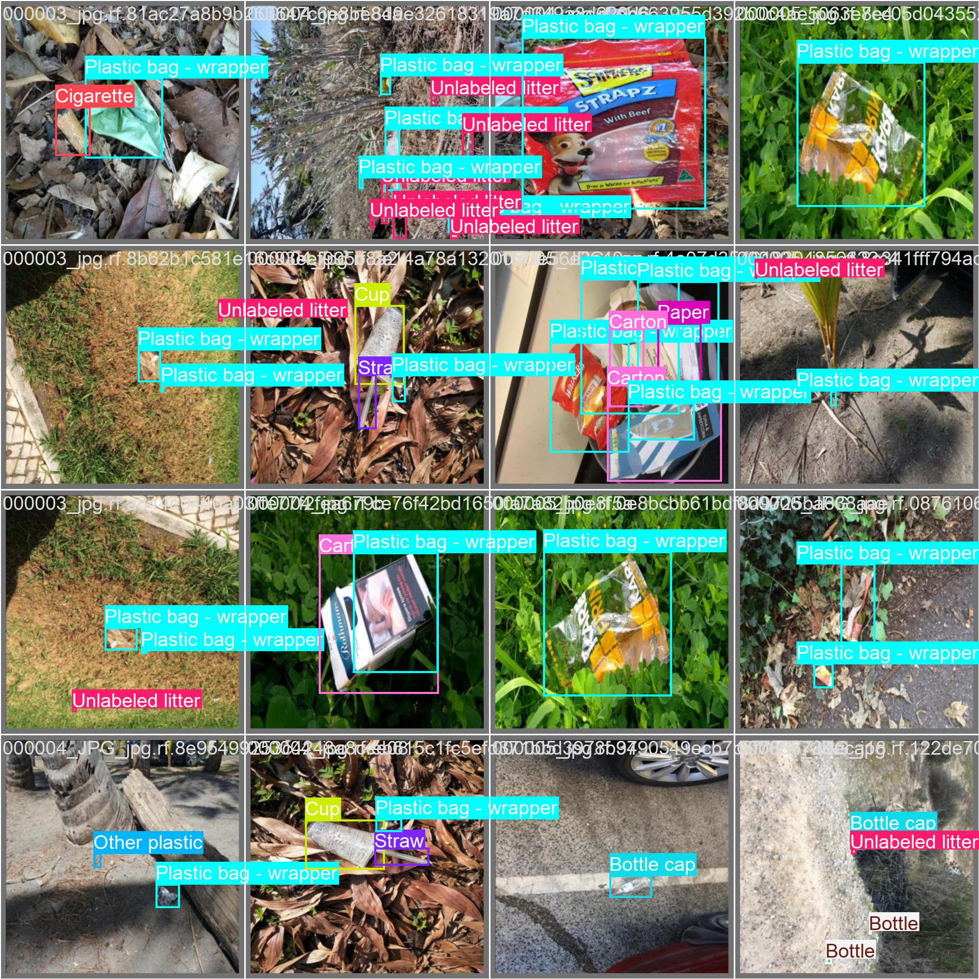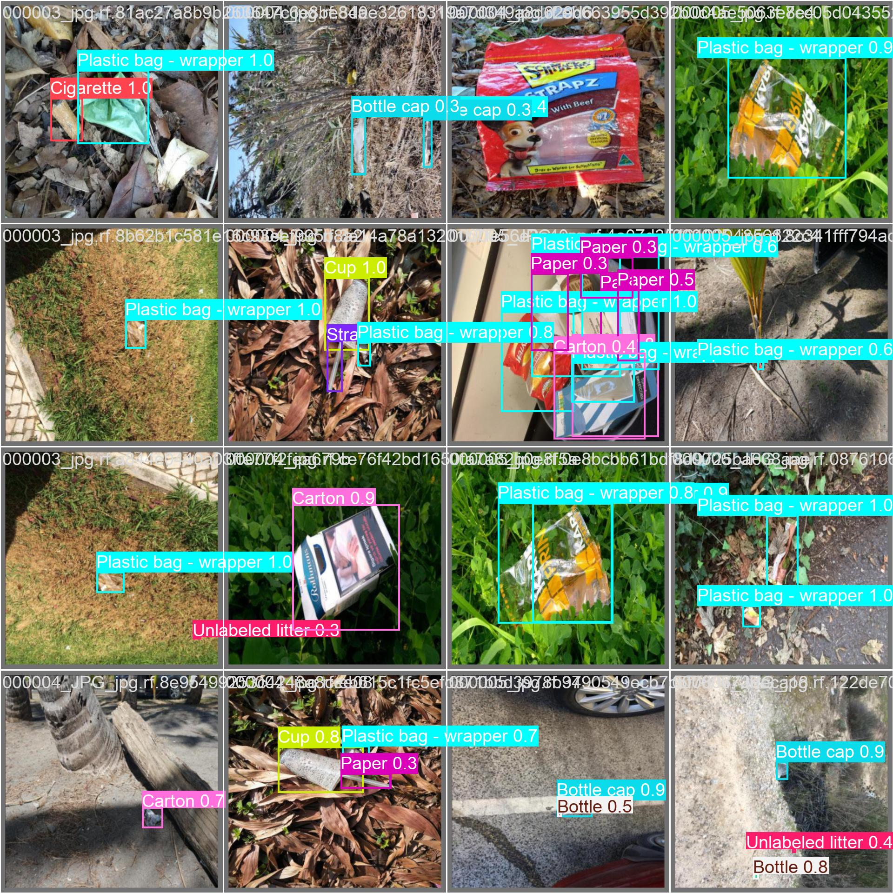

**6. Analysis & Discussion**

The experimental results indicate that YOLOv8n provides reasonable baseline performance for trash object detection while maintaining computational efficiency. The relatively higher precision compared to recall suggests that the model is conservative in making predictions, favouring correctness over completeness. This behaviour is common in lightweight object detection models and helps reduce false positives but leads to missed detections.

The moderate mAP scores can be attributed to several factors. First, the TACO dataset contains a large number of object categories with high intra-class variation, making detection inherently challenging. Second, the nano variant of YOLOv8 prioritizes speed and efficiency over representational capacity, which limits its ability to detect small or overlapping objects accurately. Additionally, the use of default hyperparameters may not be optimal for this dataset.

Despite these limitations, the results demonstrate that YOLOv8n is a suitable choice for real-time and resource-constrained applications. Performance could be improved by increasing the number of training epochs, performing hyperparameter tuning, applying stronger data augmentation, or using a larger YOLOv8 variant (such as YOLOv8s or YOLOv8m).